Tektronix 4010 and 4014 Storage
Tube Terminal Emulator
Table of Contents
Introduction 2
Getting started 5
Important features of tek4010 5
Installation and first tests 5
Connecting to systems 7
Terminal modes 7
Establishing a connection 7
Using tek4010 with SimH and the PiDP-11 8
Terminal behavior and limitations 8
Using Tek4010 as a plotter 10
Advanced features 11
Command line options 11
APL mode 12
Screen resolution 13
Using other fonts 13
Making grayscale images for tek4010 13
Using tek4010 on a slow system 14
Background and documentation 15
Manuals 15
Historically interesting facts about the ARDS terminal 15
Miscellaneous 16
Contributors 16
The usual disclaimer 16

Introduction
tek4010 is a Tektronix 4010, 4013, 4014 and 4015 terminal emulator for Linux, macOS and Windows systems. It reproduces the behavior and appearance of the original Tektronix storage tube terminals as closely as possible in a modern window environment.

The emulator supports both historical Tektronix graphics applications and terminal operation on modern systems. Typical applications include displaying historical plot files, connecting to historical Unix systems, and communicating with real or simulated DEC and Unix systems using ssh or telnet.

The main design goal of tek4010 is historical behavior rather than modern terminal functionality. In particular, tek4010 attempts to reproduce the appearance of the original storage tube display, including the bright drawing spot and its fading behavior.

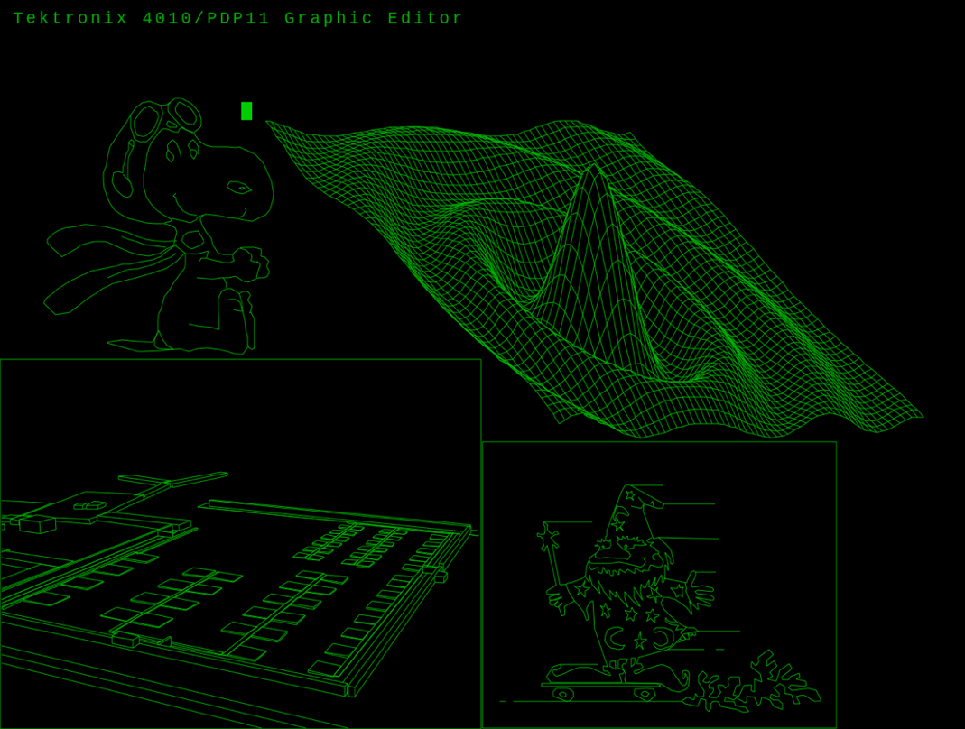

Below is a screen shot of the spacelab from the ICEMDDN CAD package running on a CDC Cyber 175 mainframe emulator:

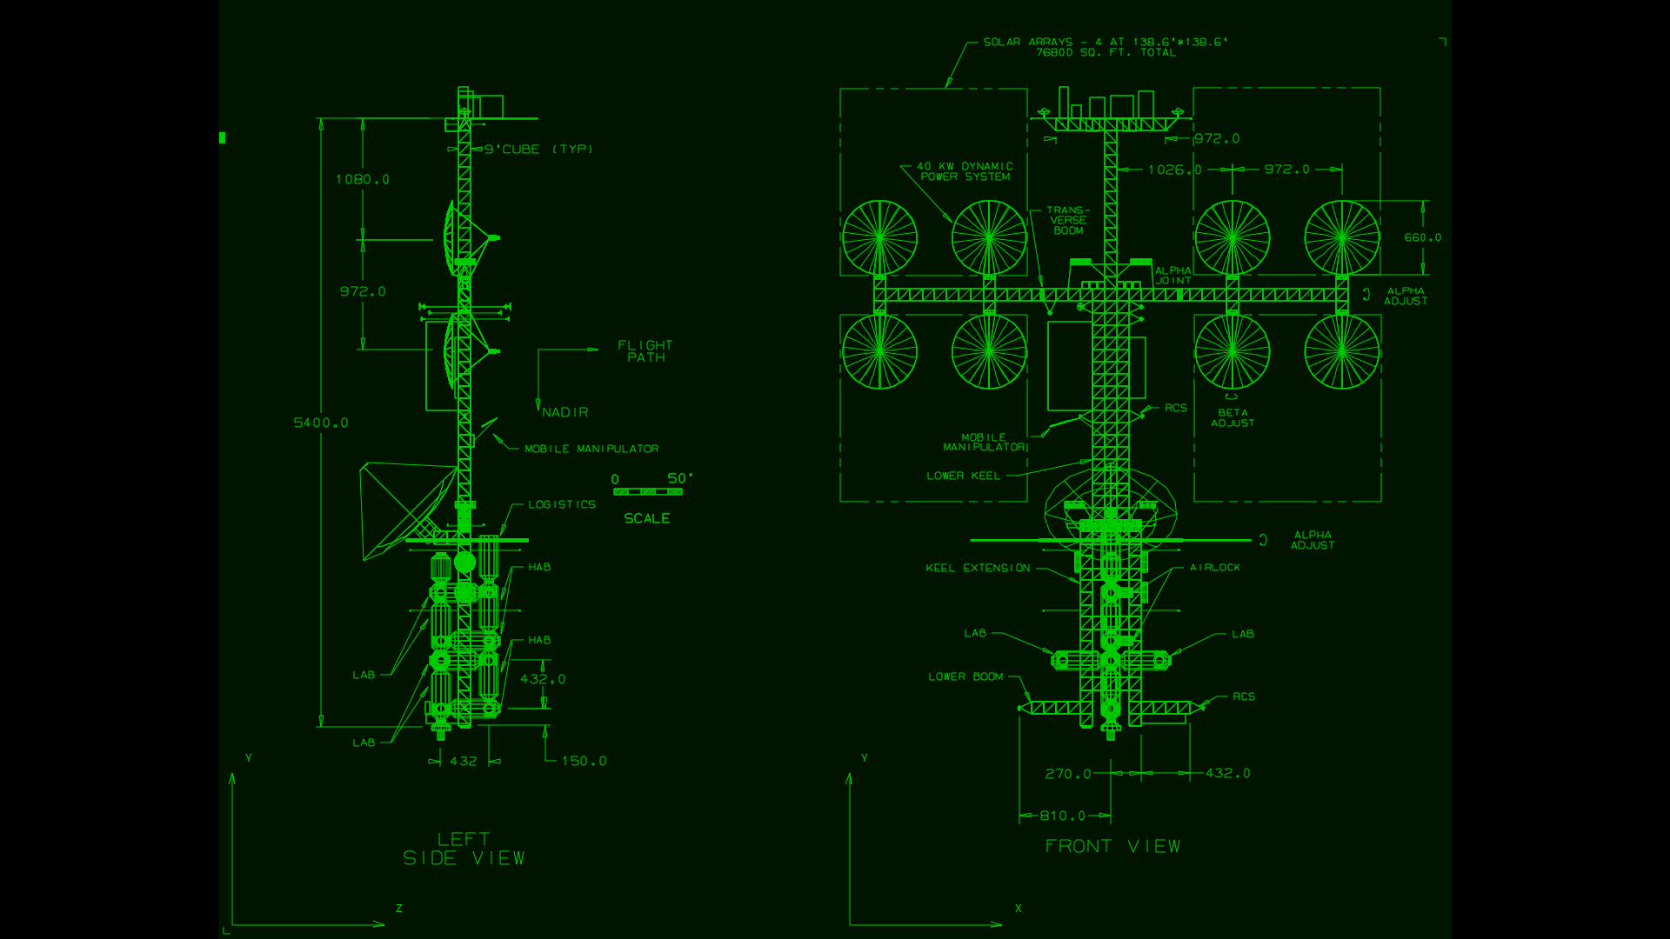

tek4010 can also display historical data for the MIT Project MAC ARDS (Advanced Remote Display Station):

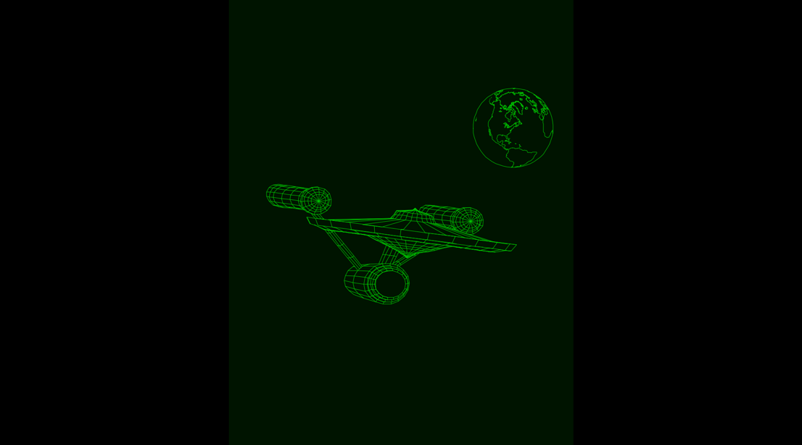

tek4010 intentionally behaves differently from modern terminal emulators such as xterm. It is not intended to emulate a VT100 or a modern full-screen terminal. Instead, it focuses on the behavior of the original Tektronix terminals and their use with historical systems and software.

Typical applications include:

- displaying historical Tektronix plot files
- connecting to historical Unix systems such as BSD 2.11
- connecting to real or simulated DEC systems
- displaying Tektronix graphics generated by historical software
- experimenting with historical terminal behavior in a modern environment

The following picture shows a scale model of the Tektronix 4010 crafted by Dave Ault using tek4010:

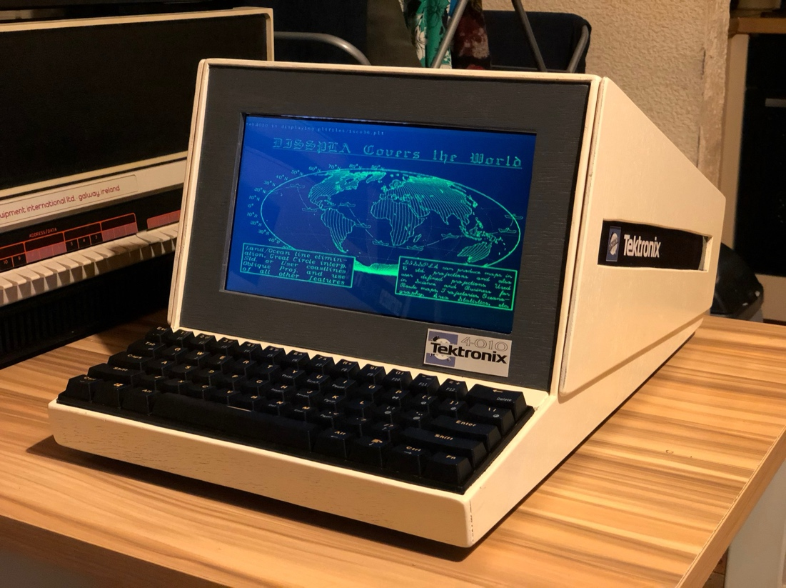

Getting started

Important features of tek4010
- Emulation of Tektronix 4010, 4013, 4014, 4015 and ARDS terminals

- Emulation of the fading bright drawing spot of the original storage tube display

- Standard window resolution of 1024 × 780 pixels

- Scaled display support for lower-resolution screens

- Full-screen mode using the -full option

- Tektronix coordinate systems: 1024 × 780 and 4096 × 3072 tek points

- Support for all Tektronix 4014 modes, including graphical input mode (GIN) and write-through mode

- Support for grayscale images using the Tektronix 4014 intensity levels

- APL character set and keyboard support for Tektronix 4013 and 4015 emulation

- Direct display of Tektronix plot files

- Interactive terminal operation using local shells, ssh and telnet

- Simulated baud rates from 300 to 19200 baud

- Support for modern Linux, macOS and Windows environments

- Tested on Raspberry Pi OS, Debian, Ubuntu, macOS and Windows/WSL

- Tested with SimH, PiDP-11, PDP-11/93, VAXstation 4000/90a, 2.11 BSD, RSX-11M+, PLOT10

- GIN mode tested with the ICEMDDN CAD package running on a CDC Cyber 175 emulator

- Raspberry Pi 4 Model B or faster recommended for best graphics performance

Installation and first tests
Important: On Windows and macOS (Macintosh) you need to prepare your system before you can start with the installation as described here. See the files macintosh.txt or windows.txt in this repository.
Install the tek4010 emulator from this Github repository:

cd
sudo apt-get install git
git clone https://github.com/rricharz/Tek4010
cd Tek4010

Compile the program on the target system:

cd ~/Tek4010
apt-get install libgtk-3-dev
make clean
make
make install

If this is your first installation, reboot the system with

sudo reboot

All further commands in this section are executed in the main Tek4010 directory:

cd ~/Tek4010

Start tek4010 in terminal mode with

tek4010

The repository contains the file test.plt, which can be used to test the emulator. While you are in the tek4010 window, type

cat test.plt

After the plot has completed, press Enter to clear the screen and continue.

If screen updates appear slow or choppy, use the -fast option:

tek4010 -fast

To display an ARDS example, start tek4010 with

tek4010 -ARDS

and then type

cat ardsfiles/trek.pic

To display a simple animation, type in the tek4010 window

cat animation.plt

To display a demonstration of historical Tektronix 4014 plot files, type in the tek4010 window

sh demos/demo.sh

Additional Tektronix 4014 plot files can be found in pltfiles/More_pltfiles in the repository. Additional ARDS plot files are available in the GitHub repository https://github.com/larsbrinkhoff/ards-files in the folder pictures.

For information about using tek4010 with 2.11 BSD Unix, see https://github.com/rricharz/pidp11-2.11bsd

Connecting to systems

Terminal modes

tek4010 can either start an interactive local shell or directly execute a command.

Starting tek4010 without additional arguments starts a local shell:

tek4010

Commands can also be executed directly:

tek4010 cat test.plt
tek4010 ssh system
tek4010 telnet system

Direct command mode is often convenient for displaying plot files or connecting to remote systems.

Establishing a connection
This can either be a real historical computer or a virtual system using simh such as the PiDP-11.
First test the remote login from your client machine into your historical system, using for example

ssh system
telnet system

Then start tek4010 using the same command

tek4010 ssh system
tek4010 telnet system

If the terminal window closes immediately, first test the ssh or telnet command outside tek4010.
tek4010 intentionally behaves differently from modern VT100 or xterm terminals. It reproduces the behavior of a Tektronix storage tube terminal. The screen is persistent and must be cleared manually when necessary.

The following keys are handled locally by tek4010 and are not transmitted to the remote system:

Clear screen

Mac: Fn-Left Arrow
Linux: Home
Windows: Home

BREAK

Mac: Option-B
Linux: Alt-B
Windows: Alt-B

All normal ASCII keys and control characters are transmitted unchanged to the host system.

Using tek4010 with SimH and the PiDP-11

tek4010 can be used successfully with SimH, PiDP-11 and historical operating systems such as 2.11 BSD or RSX-11M+.

Important: Do not run tek4010 through screen, tmux or similar terminal multiplexers. These programs filter or reinterpret the terminal data stream and therefore interfere with Tektronix graphics output.

For this reason, tek4010 should always be connected directly to the target system using ssh, telnet or a direct local connection.

When using tek4010 with the PiDP-11 console, it is recommended to start SimH directly rather than through the standard screen-based startup scripts.

Do not disconnect or close the terminal window while SimH or the historical operating system is still running, because this may terminate the emulator immediately.

Terminal behavior and limitations

tek4010 is not a VT100 or xterm emulator. It reproduces the behavior of the original Tektronix storage tube terminals as closely as possible in a modern window environment.

The screen of a Tektronix storage tube terminal is persistent. Characters and graphics remain visible until the screen is cleared. Unlike modern terminal emulators, there is normally no automatic screen refresh or scrolling.

For this reason, tek4010 behaves differently from modern terminals when used interactively. Simple command-line operation works well, but full-screen terminal applications are generally unsuitable.

The default local shell used by tek4010 is sh. This shell behaves well with the limited line-editing capabilities of the original Tektronix terminals and therefore provides a historically appropriate user interface.

In default shell mode, tek4010 uses TERM=tek4014 in order to provide terminal behavior compatible with historical Tektronix software and Unix systems.

tek4010 supports a minimal form of line editing compatible with the behavior of the original terminals. The delete key moves the cursor one character position to the left, allowing incorrect characters to be overwritten. Characters are not removed from the persistent screen.

The following types of applications are not recommended for use with tek4010:

• full-screen editors such as vi

• curses-based applications

• screen, tmux and similar terminal multiplexers

• applications which require extensive cursor positioning or screen rewriting

Such applications assume a modern cursor-addressable terminal and therefore interfere with Tektronix graphics operation and persistent-screen behavior.

tek4010 always communicates with the child process through a pseudo terminal (PTY). This allows historical operating systems and Unix software to interact with tek4010 as with a real terminal device.

If tek4010 is started without an explicit command, a local interactive sh shell is started automatically. This shell is configured for behavior compatible with the Tektronix storage tube terminals.

When an explicit command is specified, tek4010 executes this command directly and does not modify the command configuration or shell behavior.

Examples
tek4010

tek4010 ssh system

tek4010 telnet system

tek4010 cat test.plt:

Using Tek4010 as a plotter
Some emulators do not allow to attach a terminal for standard input and output, but are able to send data to a file. An example of such an emulator is my own simulator based on a home built 6502 system. The original system was not made for attaching a terminal, but could send formatted and raw data to an attached printer or plotter.

tek4010 can be attached to such an emulator as a pure plotter or printer, by monitoring the file created on the fly, and printing or plotting everything sent to that file while it is appended. The command to use in this case is

tek4010 tail -f printout.txt

where printout.txt is the output file created. The file needs to exist when tek4010 is started, and tek4010 displays whatever is already in that file, and keeps monitoring that file and displaying anything which is appended. Note that it is essential that the data is not filtered during the output process, because the tek4010 plotting code is 7 bits binary. Bit 8, the parity bit, is ignored.

Advanced features

Command line options
The tek4010 command uses the following syntax:

tek4010 [options] [command [command options]]

If no command is specified, tek4010 starts an interactive local shell.

Commands include, for example, ssh, telnet, or cat.

The following options are available:

-exit
Close the window after the command has finished.

-raw
Do not execute an automatic carriage return (CR) after a line feed (LF).

-tab1
Insert a blank instead of a tab to the next 8-character column.

-b100000, -b38400, -b19200, -b9600, -b4800, -b2400, -b1200, -b600, -b300
Emulate a baud rate. The default is 19200 baud. The original Tektronix 4010 supported up to 9600 baud, while the 4014 could reach 100000 baud with a special interface. Lower baud rates can be used to emulate 1970s modem performance.

-full
Open a full-screen window using the full resolution of the 4014 with the enhanced graphics module scaled to the window size. Press Ctrl + C to close the window.

-fullv
Open a decorated window using the maximum available vertical space. The full resolution of the 4014 is used, scaled to the window size.

-half
Open a decorated window using half of the screen width. The full resolution of the 4014 is used, scaled to the window size.

-ARDS
Enable display of ARDS graphics data.

-APL
Emulate a Tektronix 4013/4015 terminal with the APL character set.

-noAutoClear
Do not clear the screen automatically when a line feed occurs at the bottom of the screen. This matches the behavior of the original hardware.

-keepsize
Keep the current font size when the screen is cleared. Some historical plot files may not reset the font size correctly when this option is used.

-hidecursor
Hide the cursor. Do not use this option in GIN mode.

-wait n
Close the window n seconds after the command has finished. This is useful for demonstrations

-fast
Use fast rendering without fading. Recommended on slower systems. This option is automatically enabled for baud rates above 19200 or when tek4010 detects slow graphics performance.

-h, --help
Display a list of available options.

APL mode
If tek4010 is started with the -APL option, a Tektronix 4013 or 4015 terminal is emulated using the alternative APL character set.

In this mode, the following key combinations are active:

ALT + N switch to APL character set
ALT + O switch to normal character set

These commands can also be sent by the host system as ESC Ctrl + N and ESC Ctrl + O.

To use APL mode, the font Apl385.ttf must be installed. Starting from the Tek4010 directory, type

cd apl ~/Tek4010/apl
./install_apl

On Linux, WSL, and Raspberry Pi OS, the installation script updates the font cache and displays a line similar to

Apl385.ttf: “APL385 Unicode” “Regular”

This confirms that the font is correctly installed.

On macOS, the font is installed for the current user. You may need to restart tek4010 if it was already running.

While still being in the apl directory, you can test the APL character set using

tek4010 -APL -noexit ./apltest

While the APL character set is active, it is possible to remap keyboard input. Any key producing a printable ASCII character (codes 32 to 127) can be translated to another character.

An example mapping file named aplkeys is provided in the apl directory. To install it, type

mkdir -p ~/.tek4010conf
cp aplkeys ~/.tek4010conf

The file is now located at ~/.tek4010conf/aplkeys. This is the file that is actually used by tek4010. If you want to modify the keyboard mapping, edit this file in ~/.tek4010conf, not the original file in the apl directory.

The file consists of two rows. The first row contains the ASCII codes of the input keys, and the second row contains the corresponding output codes. Each position defines one mapping.

To use keys together with the left Alt key, add 128 to the value in the first row.

It is also possible to generate overstrike glyphs by adding a second character code multiplied by 256 in the second row.

You can modify the aplkeys file in ~/.tek4010conf to match your keyboard layout and country-specific settings.

Screen resolution
The tek4010 emulator creates a graphics window with a resolution of 1024 × 780 points. This corresponds to the display size of the Tektronix 4010 and the Tektronix 4014 without the enhanced graphics module.

Modern systems such as the Raspberry Pi can handle sufficiently high refresh rates at this resolution.

The emulator also supports Tektronix 4014 graphics code with the enhanced graphics module. In this case, the full coordinate range is accepted, but the lowest two bits of each axis are not used, as on a 4014 without the enhanced graphics module.

When started with the -full, -half or -fullv options, tek4010 uses the full 4K resolution of the 4014 with the enhanced graphics module, scaled to the actual window size.

Use Ctrl + C to close the tek4010 window.

The BORDER constant in main.h can be adjusted to control the space reserved for window decorations and desktop panels when using the -fullv option.

Using other fonts
The font used by tek4010 is defined in tube.h. If you prefer to use a different font, define STANDARD_FONT and STANDARD_FONT_SIZE in tube.h and recompile the program.

Making grayscale images for tek4010
The Tektronix 4014 was able to display grayscale images using the special point plot mode, which was state of the art in the 1970s. The grayscale was limited to 64 levels and was highly nonlinear.

Very few such images are still available today, but new images can be created using the make-tek-image tool.

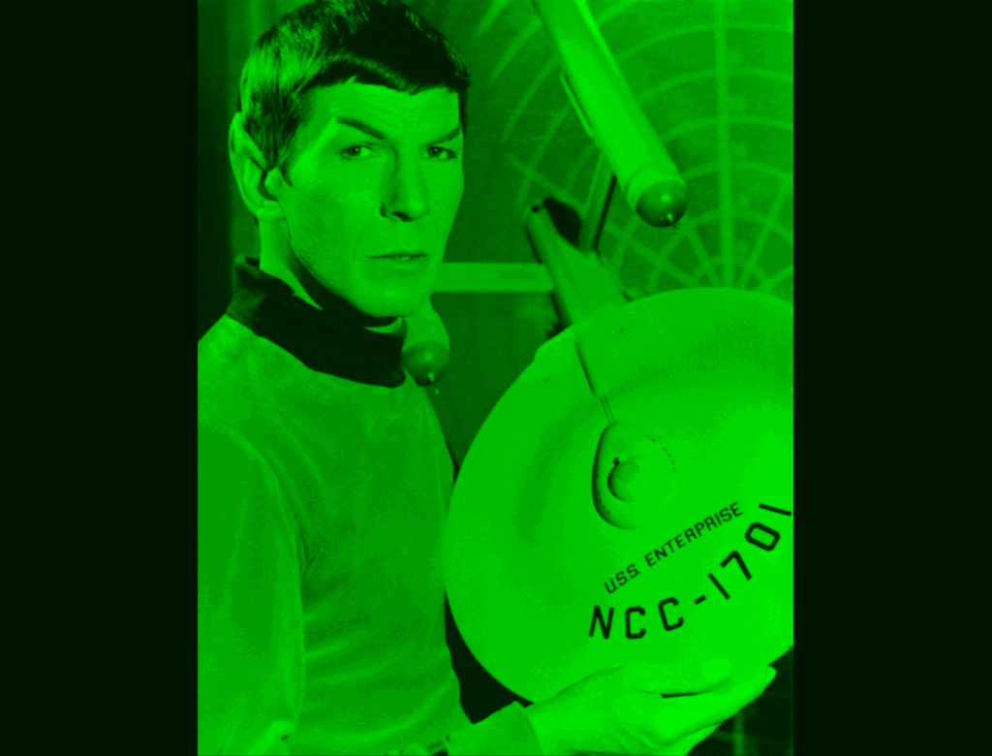

Using tek4010 on a slow system
On slower systems such as the Raspberry Pi 3, screen refreshes may be too slow and the display may appear choppy.

In this case, start tek4010 with the -fast option to enable faster rendering without fading.

The -fast option is automatically enabled for baud rates above 19200.

Background and documentation

Manuals
Documentation for the original Tektronix terminals is available in the “manuals” folder. This manual for the tek4010 emulator is provided in the Tek4010/docs directory as Manual.pdf.

Historically interesting facts about the ARDS terminal
The ARDS was a pioneering storage tube display terminal. It already supported a three-button mouse as a graphical input device, as described in the 1971 thesis:

Rhine, George Irvin Jr., “A hardware and software interface between a graphics terminal and the SCC 650 computer” (1971), Masters Theses, 5508, page 21
http://scholarsmine.mst.edu/masters_theses/5508

Detailed photographs of the terminal and the original mouse built by CDI can be found in the 1968 ARDS manual (see the manuals folder).

Miscellaneous

Contributors
The storage tube emulator and the Tektronix 4010/4014 decoder were written by René Richarz.

The ARDS decoder was written by Lars Brinkhoff, who also provided historical documents and ARDS plot files.

Teunis van Beelen developed the helper program rs232-console for serial connections.

Dave Ault tested the serial link with a PDP-11/73.

Historical Tektronix 4014 plot data was provided by Jos Dreesen.

Special plot mode images with variable brightness were provided by Monty McGraw, who also contributed to debugging this mode.

The spacelab plot data from the ICEMDDN CAD package on a CDC Cyber 175 emulator was provided by Nick Glazzard, who also made substantial improvements to GIN mode.

CP/M GSXBASIC plot files were provided by Udo Munk.

Johnny Billquist provided extensive feedback regarding historical terminal behavior, DEC operating systems and terminal compatibility.

Thanks to Ian Schofield for critical feedback and a code snippet for dashed and dotted lines, and to Oscar Vermeulen and Mark Matlock for their support.

The manuals were obtained from bitsavers.org.

OpenAI ChatGPT assisted with software design discussions, debugging support, cross-platform testing ideas, code snippets and documentation work.

Thanks also to all others who contributed ideas, assisted with debugging, and helped preserve historical data.

This program is the result of a community effort.

The usual disclaimer
This program is distributed in the hope that it will be useful, but WITHOUT ANY WARRANTY; without even the implied warranty of MERCHANTABILITY or FITNESS FOR A PARTICULAR PURPOSE.

